Title (Times New Roman, size 14, centered and bold)
Full Name,ª Full Name^{b} and Full Nameª* (Times New Roman, size 12 and bold. Underline the name of the author who will present the article. Specify the corresponding author by *)
ªDepartment of --------, Faculty of --------, University name, City, Country
^{b}Department of --------, Faculty of --------, University name, City, Country
*E-mail: example@example.com
(Times New Roman, size 11, italic and centred)
Keywords: minimum 3 and maximum 5 words which are separated by commas and placed in one line. (Times New Roman 11pt)
Abstract
Each paper should include an Abstract in a single page which summarizes the subject, aims, research method and a summary of the articleʼs results. The minimum and maximum number of abstract words should be 150 to 400 word. The text must be in Times New Roman font size 12 with a line spacing of 1, and be justified. The first line of subsequent paragraphs should be indented at 0.75 cm. Use brackets (e.g. [1]) to mark citations in text. Authors may include one figure, table, or chart within the abstract to enhance clarity or illustrate key findings (Scheme1).
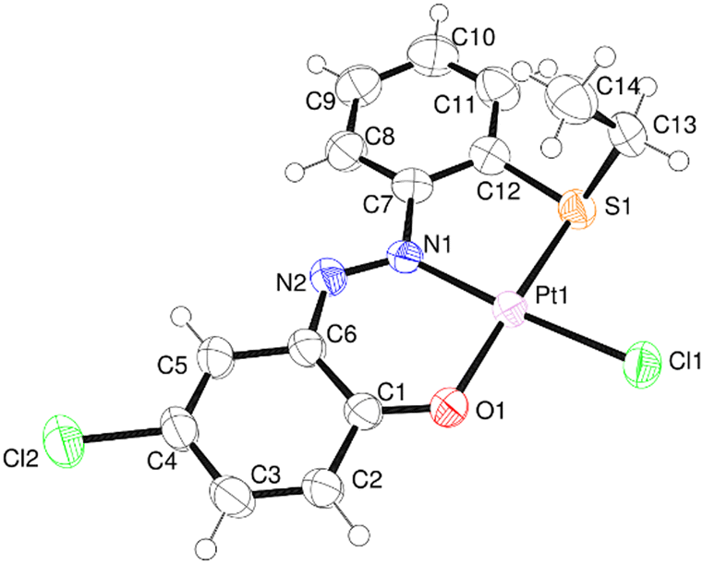
Scheme1: Use Times New Roman 11 to explain your scheme.

The abstract should not exceed from one page.
References
[1] A. Surname, B. Surname, and C. Surname, Journal Title, 2017, 35, 3523.
(Times New Roman 10) (Max 4 Refs)



